NAME – PRAKHAR BULIYA

SAPID – 500069525

 ROLLNO – 36

BRANCH – CSE OSS B-1

GIMP MID-TERM PROJECT (Open SOURCE GRAPHICS TOOls)

# Table of Contents

Phase 1- Cricketing Idol (Rohit Sharma)

Steps…………………………………………………………………………………….

Phase 2- do channels effect your Image?

# PHASE 1

# Cricketing Idol (Rohit Sharma)

## STEPS –

## IMAGE-

1) Choose the image you want to make and open it using GIMP.

2) Open a new layer using LAYER tab and use this layer as the background layer.

3) Using the path select tool make the shape of His face, Helmet, Cricket bat,

Jersey , Batting Gloves etc.

4) And Simultaneously using the paintbrush and bucket-fill tool colour the objects using appropriate colours.

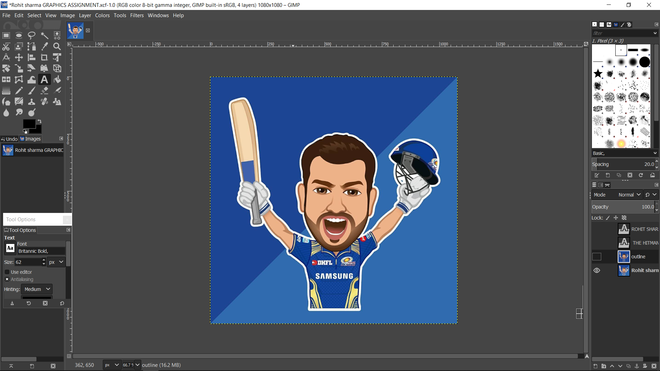

*ORIGINAL IMAGE THAT I USED AS MAIN IMAGE.

## TEXT-

5) For the text use the TEXT tool and select the area in which the text has to be written.

TEXT—CHAMPION (Font Size- 62)

ROHIT SHARMA (Font Size-40)

Kerning – 5 so that the individual alphabet is clearly visible and readable.

Font Style- I’m Using SNAP ITC for his name and his tag. As it Describe Him better in coolness or we can say attractiveness. This font is showing it is an elegant Person.

Font size-

CHAMPION—I used font size 62 For work CHAMPION to highlight it more And make the POSTER look more Attractive.

And,

ROHIT SHARMA- I used Font size 40 so which was perfect as it was not even covering the CHAMPION and also it was still readable easily.

6) Then I described his best Innings figure so far in one-day international’s which is still a world record. That was against Sri-lanka on 13th November 2014 at Eden Gardens Kolkata ,where he made 264 of 173 deliveries including 9 six’s and 33 four’s.

Font style - Lucida Sans Typewriter Semi-Bold Semi-Condensed

That was because it included Digits.

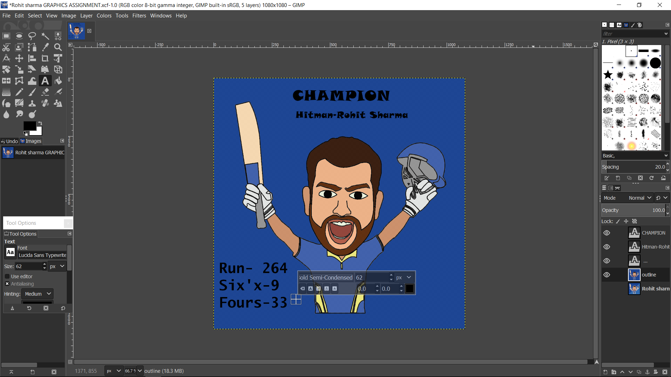

*TEXT 1

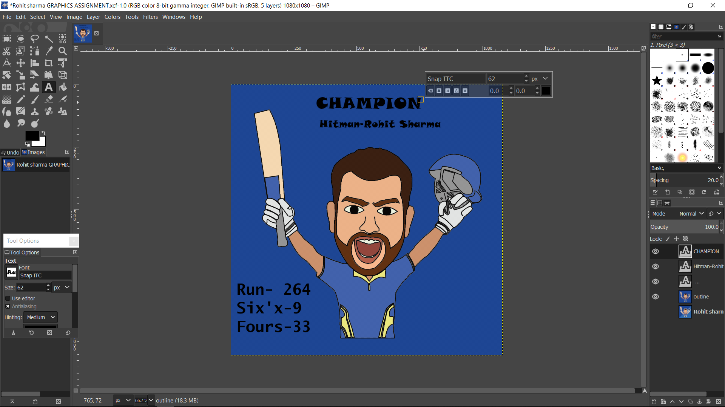

*TEXT 2

# FINAL OUTCOME-

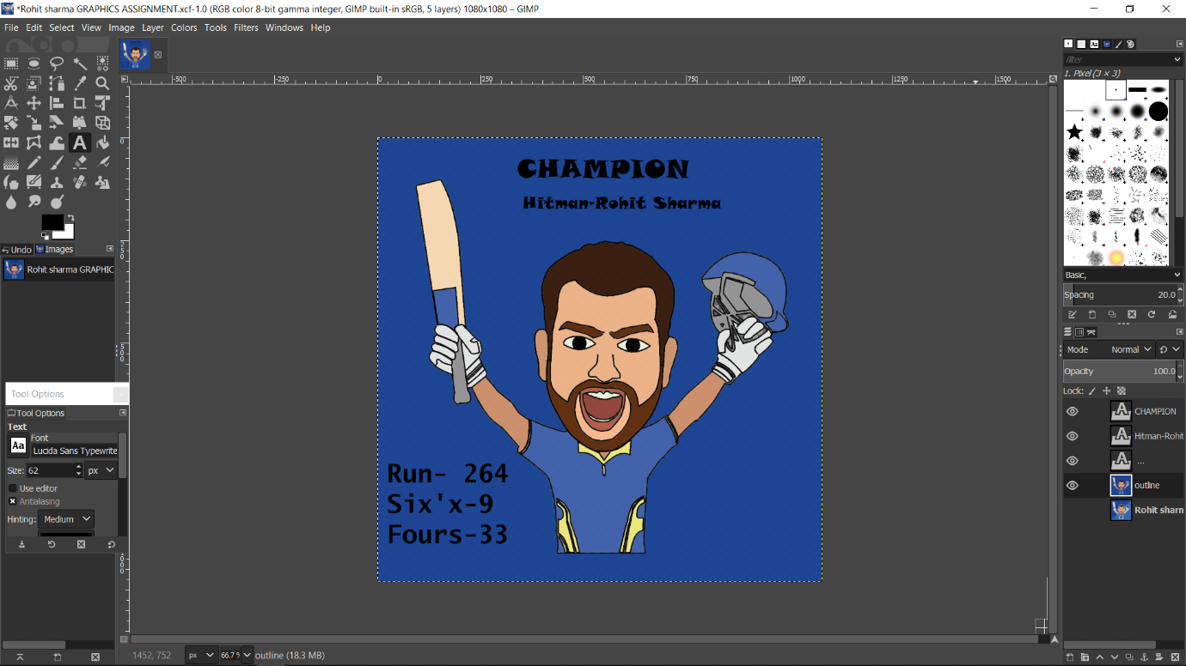

# Q- Do Channel effect your Image.

Using only the Red channel –

Using this channel highlights only the red colour in every pixel. Here we can see that the font cannot be seen clearly as the black color is similar to the red channel. Also only the red and black colours can be seen in the image.

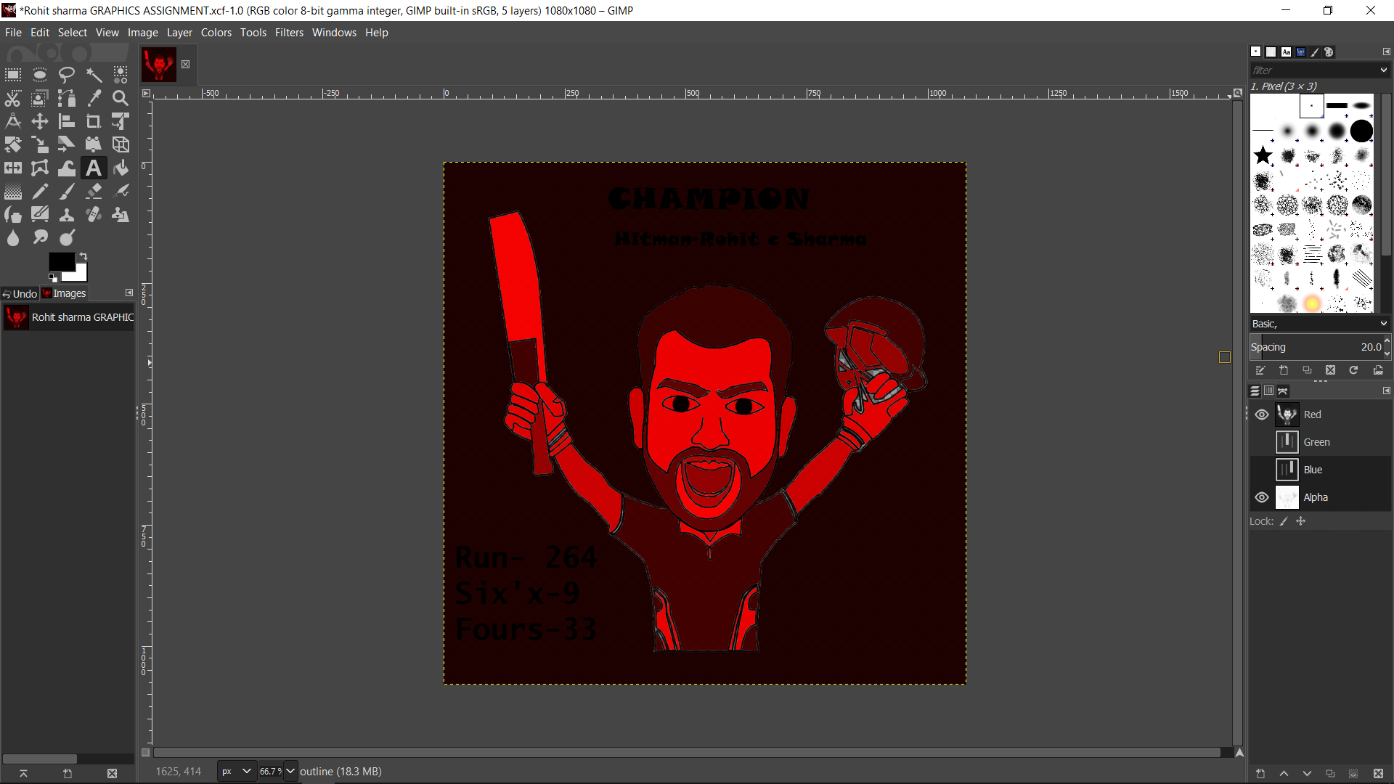

Using only the Green channel –

Using this channel highlights only the green colour in every pixel. Here we can see that the font is Clearly visible and only green and black colours are visible.

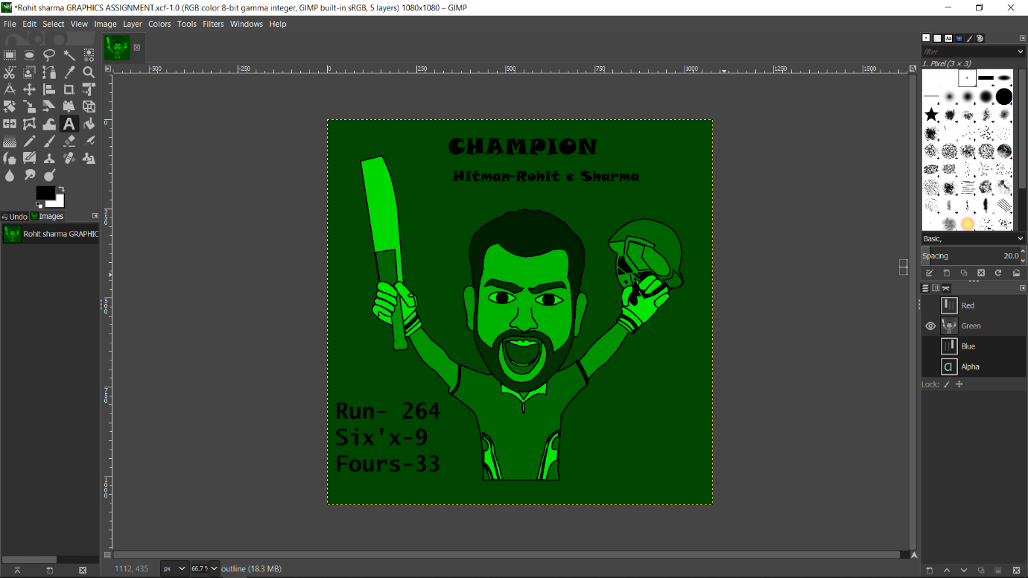

Using only the Blue channel –

Here we can see that the font is clearly visible and only blue and black colours can be seen where the part having the blue colour in the picture is more highlighted than other parts.

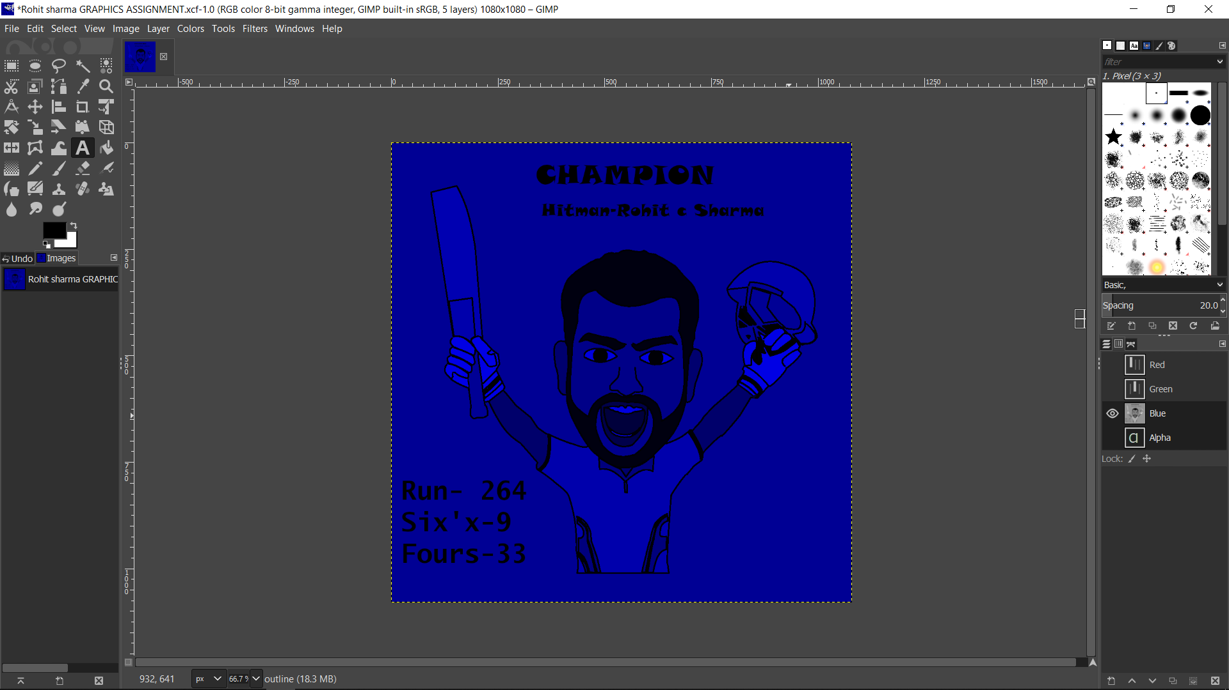

Using Blue and Green Channel –

Here we can see that the font is visible in here And also the yellow and brown colour are slightly visible too.

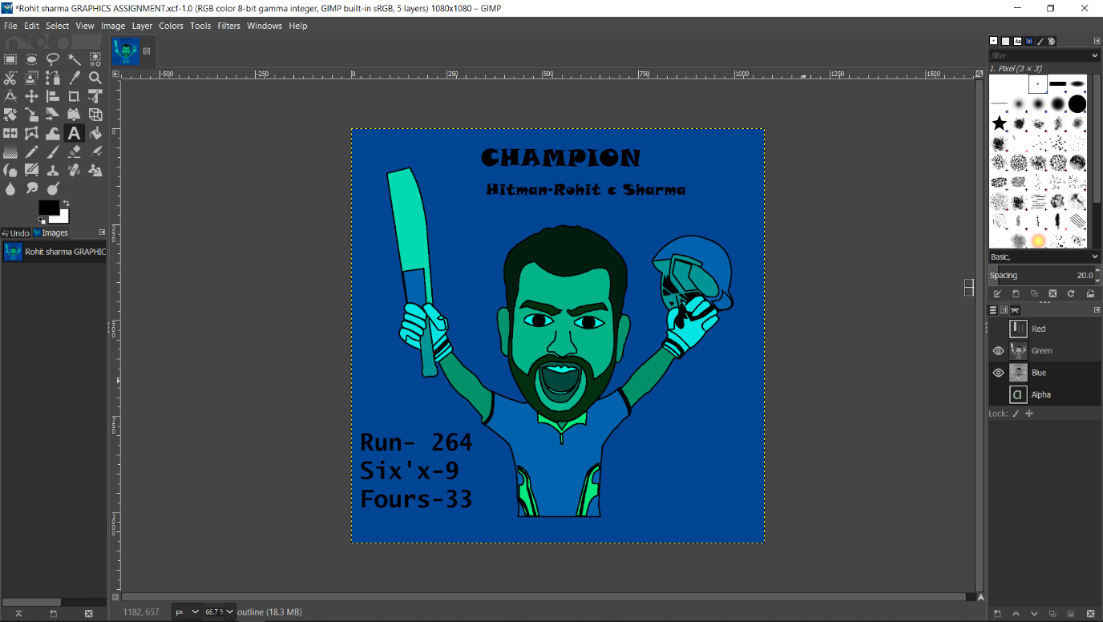

Using Blue and Red Channel—

Here we can see that the font is clearly visible and picture has a tint of pink and we can also see the shades of the original picture.

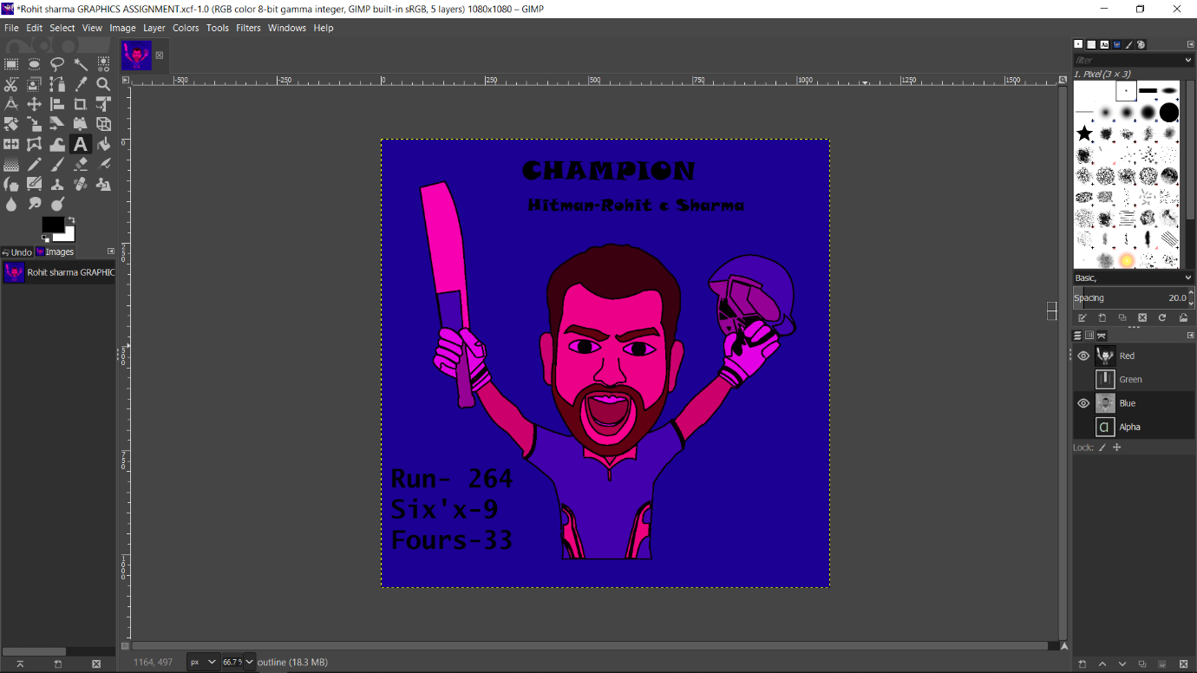

Using Red and Green Channel—

Here we can still see the fonts clearly. Here every part of the image is a bit green. Blue is totally converted into green. We can see brown with a bit shade of green.

